

Trackmatic

Integration Requirements Specification Document

Table of Contents

What we do3

How to use this guide3

Our graphical process used to integrate4

Section A5

**Part 1** Connection Types

SQL5

XML or JSON6

CSV7

**Part 2** Required Fields

Route Information11

Action Information12

**Part 3** Creating The Integration Agent

Trackmatic’s System16

External or Client’s System16

**Part 4** Finalise and Test

Testing and Training17

Section B4

**Part 1** Creating Your Own Integration Agent

Briefing18

**Part 2** Required Fields

Route Information11

Action Information12

**Part 3** Authentication

Provide Access18

**Part 4** Create Agent

Snippets and Samples19

Sample Model20

# What we do

In short, Trackmatic provides unique tailor-made software solutions to fleet operators and fleet management of On-Road Execution™ regardless of the fleet size.

We offer a holistic business solution to our clients, meeting their unique and complex requirements. We work together with them to provide insight into the finer workings of their operations, thereby increasing efficiencies and enabling greater levels of satisfaction among their customers.

Resource optimisation and service excellence are key outcomes of the solution, resulting in higher profits and driving down costs. This is where the true value of the solution is gained.

# How to use this guide

The graphical process shown below depicts the various sections and parts of the document which relate to the way in which you can integrate with trackmatic.

Following each node leads to the next process to be completed until having a smooth-running integration. The process of following a path in the diagram below shows what each node allows for the next steps to be followed.

Top left corner of the box shows which section to refer to while at the left of each box shows its relative part heading it falls under.

Sample scenario:

Integration with trackmatic where trackmatic creates the integration using a CSV file, connecting via Email to push data is in the following path:

* Trackmatic-> Trackmatic Integration -> CSV Email-> Required Fields -> Trackmatic’ s System -> Testing and Training

**Our graphical process used to integrate:**

Follow a path and make reference to each section, part and label to complete the integration process.

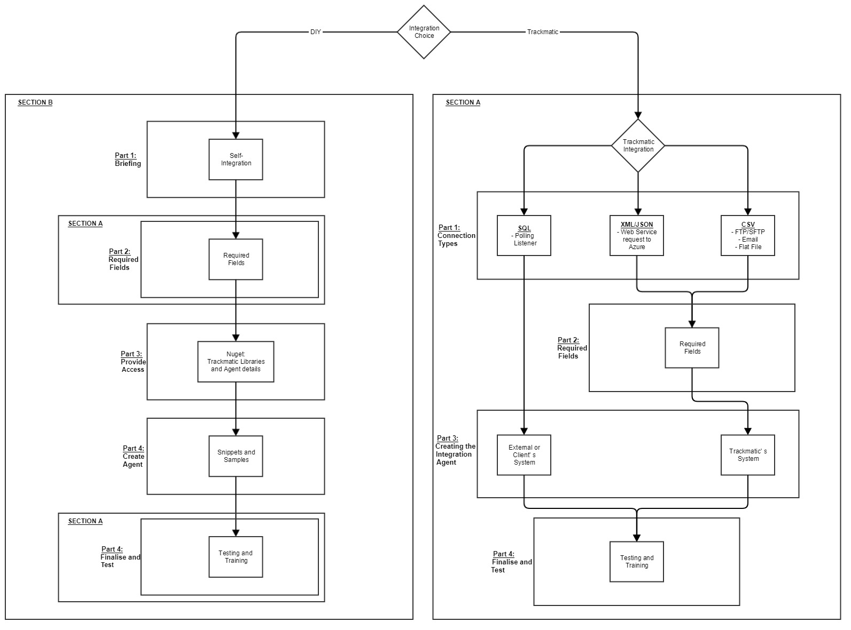

**Section A**

Part 1: Connection Types

**SQL**

*Polling Listener*

This is installed as a service on the client’s local server or machine. It listens to a 'Trackmatic-Changes' table placed within the client’s database. This table records all the changes been made to the relevant client’s tables needed to use Trackmatic’ s services. These changes in relation to the tables are then traced, picked up and updated in Trackmatic.

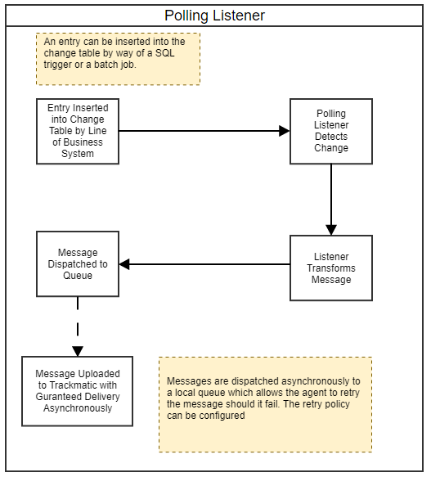

**XML or JSON**

*Web Service Request To Azure*

The client presents the required data to our web service in XML or JSON. Upon receiving it, it is then mapped and uploaded into Trackmatic.

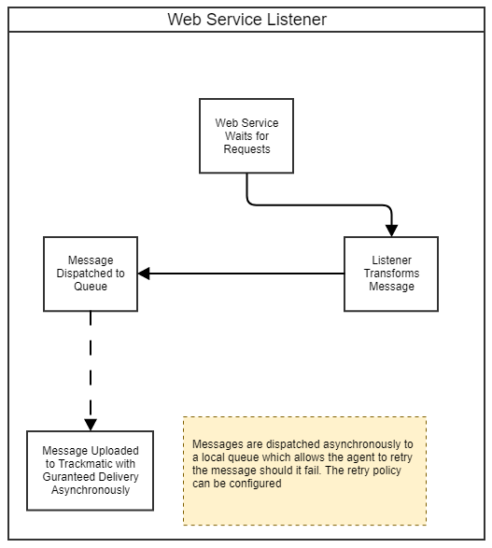

**CSV**

*SFTP/FTP*

The client drops an excel extract (CSV) to the SFTP/FTP server containing all the relevant data to use Trackmatic services. The integration agent polls the directory of the SFTP/FTP for the file. If an extract is picked up, it is then read in and uploaded into Trackmatic. The client can choose to use their own SFTP/FTP server (preferable) or Trackmatic’ s SFTP/FTP server.

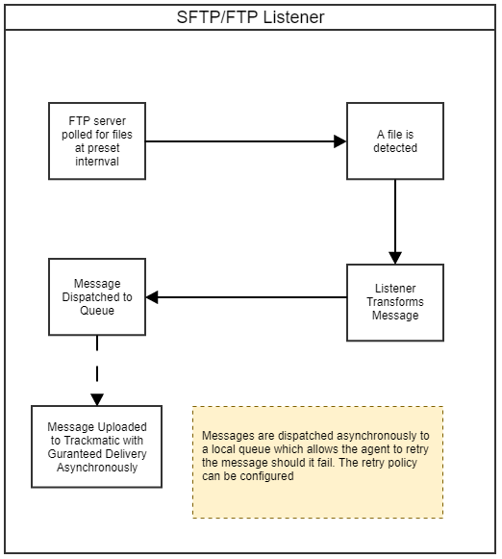

*Email Listener*

The client emails an excel extract (CSV) containing all the relevant data to use Trackmatic’ s services to an email address provided by Trackmatic. The integration agent which is running on Trackmatic’ s server will then pick up this email. If an extract is picked up within the email, it will then be read in and uploaded into Trackmatic.

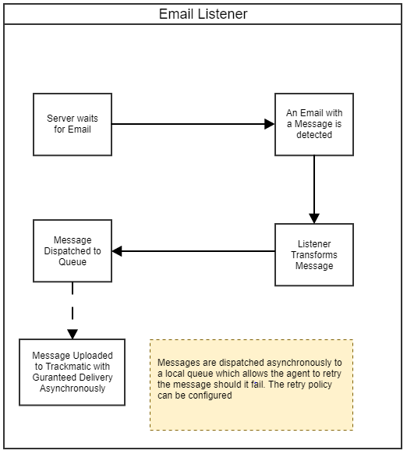

*Flat file Listener*

Very like SFTP/FTP, the client drops an excel extract (CSV) containing all the relevant data to use Trackmatic’ s services onto a local directory in Trackmatic’ s server. The integration agent which is running on Trackmatic’ s server will poll the directory for the file. If an extract is picked up, it is then read in and uploaded into Trackmatic.

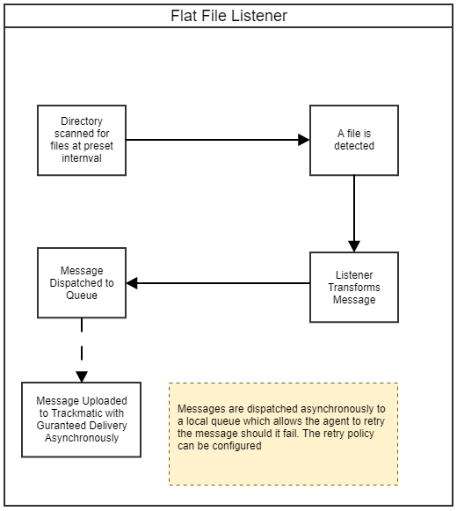

Part 2: Required Fields

Below shows a diagram of the fields that will be required depending on the data you have.

A simple scenario of the two cases:

1. **Route** **information** may include the data received from a Planning tool which provides you with a vehicles route and stops to be made for a specific period. This also including action information defined in point 2 below.
2. **Action information** includes data about the stop to be made. This may be invoice data, delivery notes, interbranch transfers, collections etc. Additional information with this is required such as the address of the stop to be made as well as any extra functionalities that trackmatic can provide per stop. These extra functionalities can be seen in the required fields.

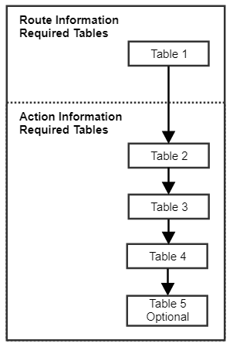

**ROUTE INFORMATION**

Route information is comprised of four fundamental sets of data and one optional:

**Table 1**: Route – This is the header information for the sequence of stops for a vehicle within an allocated period.

**Table 2**: Action – Type of stop to be made. (Delivery, Collection, IBT, etc)

**Table 3**: Entity – This is essential the sell to.

**Table 4**: Deco – This is essential the ship to.

**Table 5**: Handling Units – Individual items been delivered (optional)

**Table 1:**

|  |  |  |  |
| --- | --- | --- | --- |
| **ROUTE** | | | |
| **A basic example of a route in trackmatic is the travel path in which a delivery is to be made.** | | | |
|  | **Field Name** | **Mandatory** | **Description** |
| 1 | Reference | Yes | A unique reference number for the route |
| 2 | Planned Start | Yes | Planned start date and time |
| 3 | Registration | No | Registration number of the vehicle being assigned to the route |
| 4 | Name | No | A name or number of the route |
| **Crew** | | | |
| 5 | Reference | Yes | Personnel Unique Identifier issued by Client |
| 6 | Name | Yes | Personnel Name |
| 7 | Type | Yes | Personnel Type (Driver or Crew) |
| 8 | Identity No. | No | Identity number of crew member |
| 9 | Cell No. | No | Cell phone number of crew member |

**ACTION INFORMATION**

Action information is comprised of three fundamental sets of data and one optional:

**Table 1**: Action – Type of stop to be made. (Delivery, Collection, IBT, etc)

**Table 2**: Entity – This is essential the sell to.

**Table 3**: Deco – This is essential the ship to.

**Table 4**: Handling Units – Individual items been delivered (optional)

**Table 2:**

|  |  |  |  |
| --- | --- | --- | --- |
| **ACTION** | | | |
| **A basic example of an action in trackmatic is an invoice along with its details for who the customer is for.** | | | |
|  | **Field Name** | **Mandatory** | **Description** |
| 1 | IsCod | Yes | Cash On Delivery Indicator |
| 2 | Reference | Yes | Unique reference number associated with the action |
| 3 | Volumetric Mass | No | The volume of the parcel |
| 4 | Weight | No | Weight of the parcel |
| 5 | Pieces | No | Number of pieces in the action |
| 6 | Unit | No | Unit of measure |
| 7 | Instructions | No | Special instructions |
| 8 | Customer Reference | No | Client supplied reference number |
| 9 | Customer Code | No | Unique client code |
| 10 | Expected Delivery | No | Date the action is expected to be executed |
| 11 | Pallets | No | Number of pallets associated with the action |
| 12 | Amount Incl | No | Monetary value of the action including vat |
| 13 | Amount Excl | No | Monetary value of the action excluding vat |
| 14 | Reference_Internal | No | Internal reference number for workflow i.e. picking slip, sales doc etc |

|  |  |  |  |
| --- | --- | --- | --- |
| **ENTITY** | | | |
| **A basic example of an entity in trackmatic is the individual stores/customers details within an area(Edgars in Mall Of Africa).** | | | |
|  | **Field Name** | **Mandatory** | **Description** |
| 1 | Name | Yes | The name of the entity |
| 2 | Reference | Yes | A unique reference number for the entity (Sell-to identifier) |
| **Contact** | | | |
| 3 | First Name | No | First name of the contact |
| 4 | Last Name | No | last name of the contact |
| 5 | Tel No | No | Telephone number of the contact |
| 6 | Cell No | No | Cell phone number of the contact |
| 7 | Email | No | Email address of the contact |
| **Requirements** | | | |
| 8 | Action Debrief | No | Success or Failure of the action that was to be executed.Per entity, it can be stated if you would like an entity debrief. |
| 9 | Cod Debrief | No | Review of Cod deliveries 1) EFT POP 2) Cash 3) No Cash 4) Accouting Pin. Per entity, it can be stated if you would like a Cod debrief. |
| 10 | Signature | No | Sign On Glass required after an action is debriefed. Per entity, it can be stated if you would like the signature feature. |

**Table 3:**

|  |  |  |  |
| --- | --- | --- | --- |
| **DECO** | | | |
| **A basic example of a Deco in trackmatic is the area/location of the entities (Mall Of Africa has entities like Edgars, Woolworths etc.).** | | | |
|  | **Field Name** | **Mandatory** | **Description** |
| 1 | Reference | Yes | A unique reference number (Ship-to Identifier) |
| 2 | Name | Yes | Common name of the DECO |
| **Address** | | | |
| 3 | AddressId | Dependant | Mandatory if 3PL or you may have multiple delivery addresses |
| 4 | IsAdhoc | Yes | Once of stop |
| 5 | Unit No. | No | Unit No. |
| 6 | Building Name | No | Building Name |
| 7 | Street No. | No | Street Number |
| 8 | Sub Division No. | No | Sub Division Number |
| 9 | Street | No | Street Number |
| 10 | Suburb | No | Street |
| 11 | Province | No | Province |
| 12 | Postal Code | No | Postal Code |
| 13 | Map Code | No | Map Code |
| 14 | Latitude | No | Latitude |
| 15 | Longitude | No | Longitude |
| 16 | MST | No | Maximum stop time |

**Table 4:**

**Table 5: optional**

|  |  |  |  |
| --- | --- | --- | --- |
| **Handling Units** | | | |
| **A basic example of a handling unit in trackmatic is the individual items/materials/goods that are been delivered.** | | | |
|  | **Field Name** | **Mandatory** | **Description** |
| 1 | Barcode | Yes | Barcode of the handling unit |
| 2 | Unit of measure | Yes | Describes the type of handling unit (carton, parcel, box) |
| 3 | Customer Reference | No | Client supplied ref number |
| 4 | Quantity | No | Amount of parcels in the handling unit |
| 5 | Weight | No | Weight of the handling unit |
| 6 | Status | No | Status of the handling unit (pending, endorsed, rejected, missing) |
| 7 | Description | No | Description of handling unit |
| 8 | Volume | No | Volume of the parcel |
| 9 | Volumetric Mass | No | Volumetric mass of the parcel |
| **Dimensions** | | | |
| 10 | Height | No | Height of handling unit |
| 11 | Width | No | Width of handling unit |
| 12 | Length | No | Length of handling unit |

Part 3: Creating the Integration Agent

Trackmatic’ s System

The pre-requisites of this stage are to:

1. Have a chosen Connection Type (Part 1)
2. Populate the Required Fields (Part 2) in a sample file that will be in the format relative to your choice in the above point then provide it to the trackmatic professional developers leading the integration.
3. The sample file should be accompanied by its relevant documentation (invoices, delivery notes, trip sheets etc.) for data integrity measures.

Note:

* This is the longest process of integration and a specific timeline can be acquired from the project manager showing the tasks that is needed to be completed.
* Due to ensuring that this integration is done efficiently and effectively whilst bearing in mind that every client is unique in the way they carry out their processes, trackmatic works iteratively to meet the needs and functionalities that we can provide to our client. Therefore, key personnel should be assigned the task of working and communicating with a trackmatic professional to get the best out of our services.

After having met the pre-requisites, Trackmatic professional developers will create a baseline agent in which users of trackmatic can provide the data to pushed and uploaded into trackmatic’ s API. This baseline agent will be iteratively worked till all functionalities are catered for.

Depending on the Connection Type chosen, Trackmatic will provide you with credentials and details for the system you will use (URL, Email, FTP/SFTP) to push data to.

External or Client’ s System

1. If trackmatic is to integrate into external systems, then Trackmatic will need to be provided with the details for the systems. For example, IP addresses, port numbers, logon credentials and firewall rules etc.
2. Guidance on where we can obtain the Required Fields (Part 2) will be needed.
3. Relevant documentation (invoices, delivery notes, trip sheets etc.) in relation to the Required Fields (Part 2) will be need to be provided for data integrity measures.

Part 4: Finalise and Test

Testing and Training

Upon completing the task of Creating the Integration Agent (Part 3), automation of providing the file to the system we have provided (URL, Email, FTP/SFTP) will need to be set up from the client’s side.

Once data is being uploaded regularly, training and testing of data integrity as well as functionalities can commence:

* Training on how to use trackmatic and all its features can be discussed with the project manager leading the integration. Training can only commence once data is being uploaded into trackmatic’ s API on its appropriate time intervals.
* During the testing and training phases, any discrepancies, bugs or additional features to be made will be applied and re-tested with the new implementation of these changes. Once again, this task may be iterative to accommodate and fix and unforeseen circumstance that may arise.

Finally, if both the client and trackmatic is pleased with the outcome of the integration, where-by the focus points and business requirements are met, we can then move over into live production. This will be scheduled to occur over a controlled period, preferably when the client is least busy. It is advised to have both the staged and live environment run concurrently until such the live production is stable.

**Section B**

Part 1: Creating Your Own Integration Agent

Briefing

When creating your own integration, make sure you fully understand the requirements of what data needs to be pushed into trackmatic.

Creating the integration agent process works as follows:

* Prepare the fields needed as can be seen in Section A – Part 2
* Select the way in which you want to push data (read from CSV, database etc.)
* Create baseline code that will read in the fields in the format you provide
* Add trackmatic’ s libraries and authentication details as in part 3 below
* Create the model and transform it into trackmatic’ s format as in part 4 below
* Place agent in secure environment which is stable
* Test and confirm data been sent to trackmatic

If there are any issues when trying to create your own integration to trackmatic then feel free to contact any of the trackmatic professional who are part of the handling the project.

Part 2:

Same as Section A – Part 2

Part 3: Authentication

Provide Access

Upon completing the task of determining which Required Fields (Section A – Part 2) is needed, you will need to start creating your own integration.

In order to make use of our framework as well as push data to Trackmatic’ s API, you will require access to its libraries and authentication to its API:

1. Trackmatic’ s libraries are accessible from NuGet use the following link:

<http://nuget.trackmatic.co.za/nuget>

1. Packages you will need to make use of are:

* Trackmatic.Rest.Client
* Trackmatic.Api.Agent.Host
* Trackmatic.Api.Agent
* Trackmatic.Api.Agent.Polling use if you are pulling data directly from a database. Trackmatic to provide Scripts if needed to use our triggers and table to listen to upon a change or insert.

1. Trackmatic will provide you with the following when authenticating to push data to our API:

* Client ID
* Integration Username
* Integration Password
* Api Address: https://rest.trackmatic.co.za/api/v1

Part 4: Create Agent

**Snippets and Samples**

**Authentication:**

Authentication should be placed in the configuration file as follows:

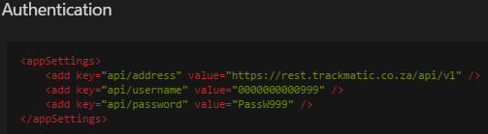

The authentication will occur in the background of the API which is built into the interface IAgent which will be used by the listener. All other instances can also be injected to the listener. Below depicts how the listener class should implement this:

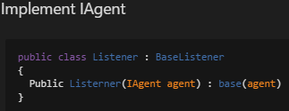

**Sample Model:**

Note:

This shows a sample of how these models are created.

The model been created is dependent on Section A - Required Fields (Part 2).

The below diagram shows the flow to be taken of which models to use for each type of stop (one to one, multiple address, adhoc). Each node in the below diagram represents the label of the snippets of the models below.

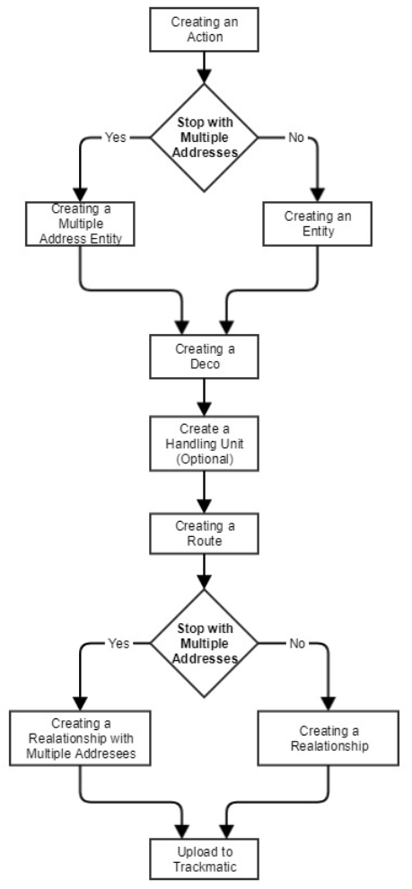

* **Creating an Action:**

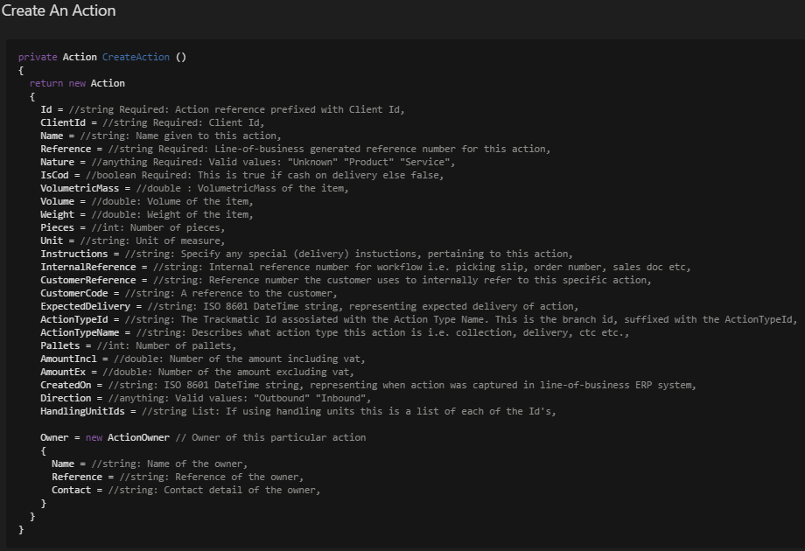

* **Creating an Entity:**

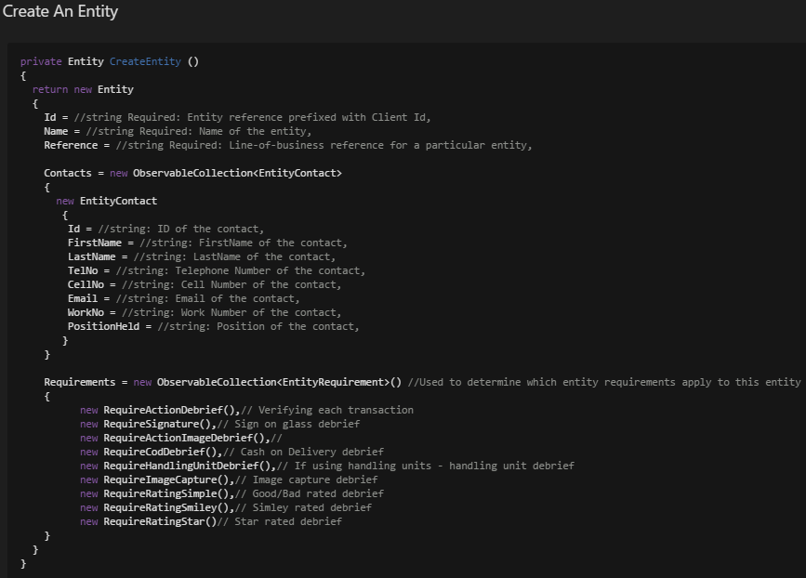

* **Creating a Multiple Address Entity**

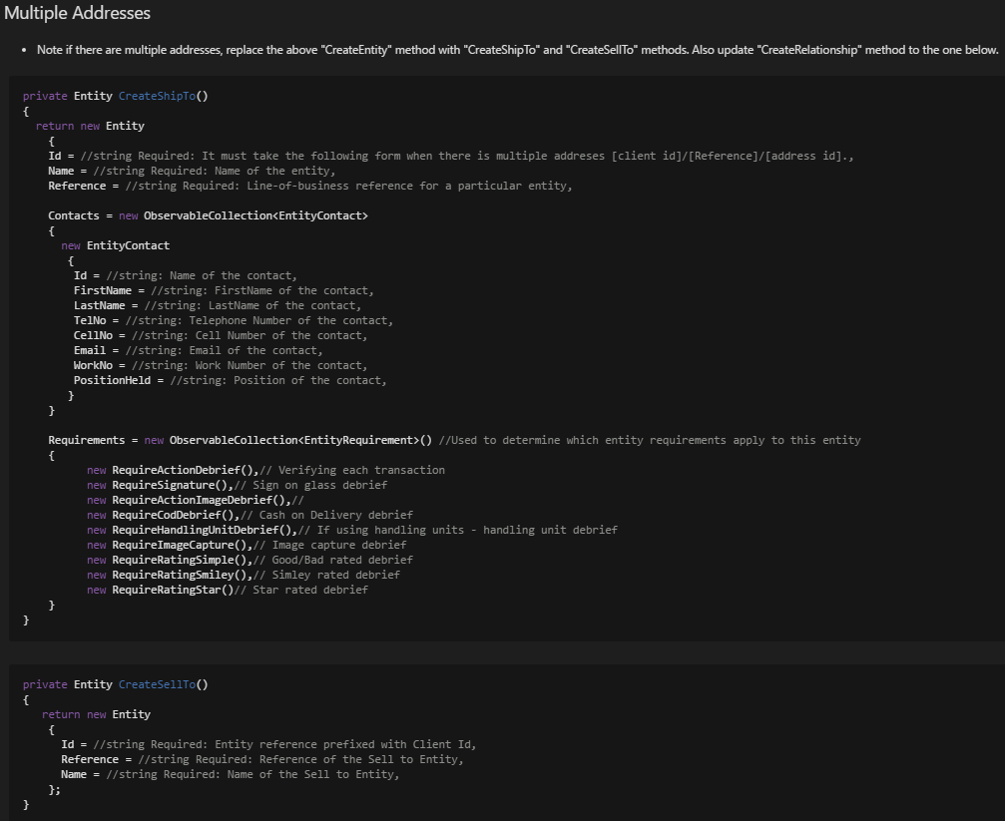

* **Creating a Deco:**

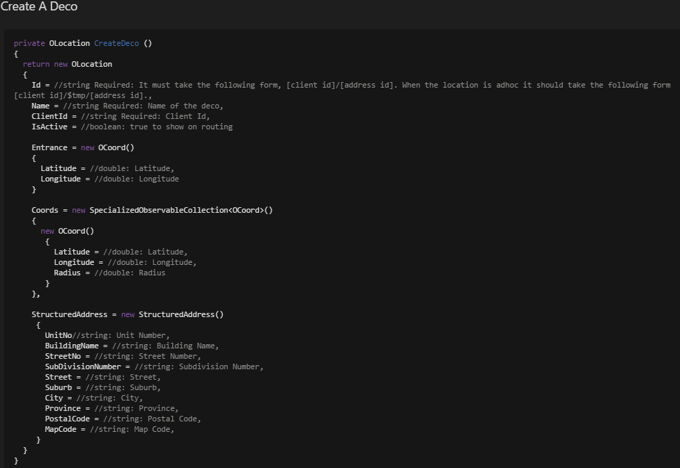

* **Creating Handling units (Optional):**

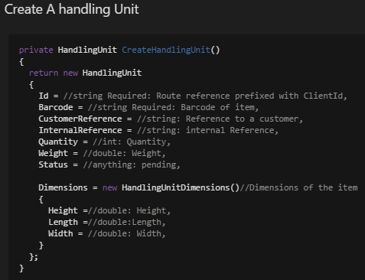

* **Creating a Route**

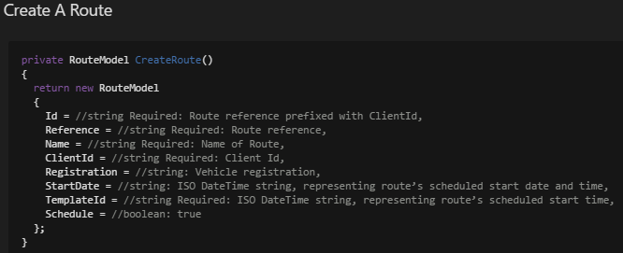

* **Creating a Relationship**

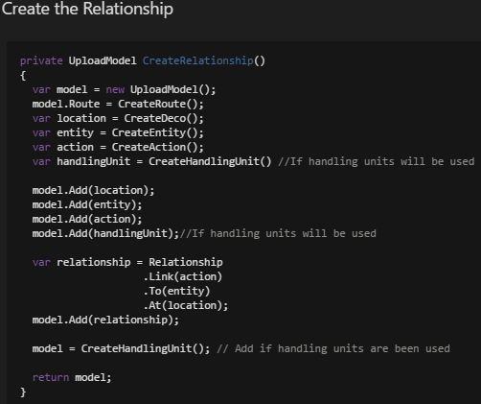

* **Creating a Relationship with Multiple Addresses**

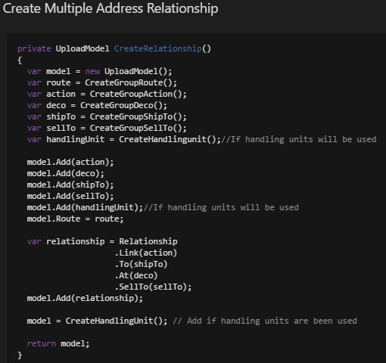

* **Upload to Trackmatic API:**

In order to upload the transformed data to trackmatic, it has to be placed in the pipeline within the listener. See below how data is transformed then dispatched to be uploaded into trackmatic.

